8.15: a) You and the snowball now share the momentum of the snowball when thrown so your speed is 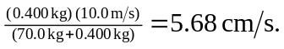 b) The change in the snowball’s momentum is so your speed is 